Learning Management System

**Use-Case Specification:** Manage Course

**Version 1.0**

**Revision History**

| **Date** | **Version** | **Description** | **Author** |
| --- | --- | --- | --- |
| 23/11/2024 | 0.1 | Draft version | Nguyễn Thị Hiền Anh |
| 24/11/2024 | 1.0 | Final version | Nguyễn Thị Hiền Anh |

**Table of Contents**

1. Use-Case Name 4

1.1 Brief Description 4

2. Flow of Events 4

2.1 Basic Flow 4

2.2 Alternative Flows 4

3. Special Requirements 5

4. Preconditions 5

5. Postconditions 5

6. Extension Points 5

7. Prototype 6

**Use-Case Specification:** Manage Courses

# **Use-Case Name**

## **Brief Description**

The Manage Course use case allows administrators to create, update, and delete courses in the LMS. It includes assigning members (students and instructors) to courses and ensuring course information is correctly managed.

# **Flow of Events**

## **Basic Flow**

*2.1.1. Access and View Manage Course View*

In the admin view, there will be an action menu on the left corner of the screen, including the actions the admin could choose, including “Dashboard”, “Manage User”, “Manage Courses”, “Report”, “Announcement”, “Monitor System”, “Configure System Setting”. When the admin chooses “Manage Course” from the list of actions on admin view, the manage course view will appear. In this view, a gallery of courses will be displayed in card view, on the right side of the action menu. Each row contains 4 cards with the size of 321x298px; there will be 2 rows in a screen, which means each column contains 2 cards in one screen. If there are more than 8 courses, the admin can see more courses in the next pages with the pagination and “<”, “>” buttons. Each page number is in a square box with a size of 32x32px, with a white background and a black number, and the chosen page number is highlighted with a square with the background color of black and the number at the center of the color of white.

In each card, below the image of the course with the size of 321x150px, there will be the ID of the course and the name of the course in 2 lines with the maximum digits number of 70; if the name and ID are too long for 2 lines, it will be displayed shorter (maximum of 67 digits with "..."). The text color of ID and name is blue, and the size is 16. The category is displayed right below the name and ID with black color and size 13. All the text will be styled with the font Roboto.

When the admin hovers over an available course in the view, the image will be blurred, and three buttons will appear, including the “View” button for the admin to view details of the course, the “Edit” button for the admin to edit the detailed information of the course or members of the course, and the “Delete” button for the admin to delete the course. The buttons should be aligned in the center and evenly spaced between each other. Each button is sized 70x30px with the background color of black and the text color of white.

The first card of the view will be the “Add a course” option for the admin to add a new course with the plus sign. The text and plus sign are blue with a text size of 16.

Above the course cards, there should be a search bar for the admin to quickly search the name or ID of the course. After entering the keywords (allowing course name and course ID), the results will appear also in card view like in the Course Management View. Beside the search bar, there should be a sorting button that allows the admin to arrange the course to view as their desire, for example, from latest to oldest and reverse, or recently added.

*2.1.2. Add a new course*

When the admin clicks “Add a course," the form “Add a new course” will appear. This form will include the information below; the required fields will have the red icon with “!”:

- Full name: The full name of the course, in text format, maximum 100 characters, is required to be filled.

- Course ID: The ID of the course; this ID should be unique and doesn’t exist in the course list available. It should be in text format, allowing both strings and numbers; a maximum of 20 characters. It is required to be filled.

- Category: The category of the course; for example, some courses belong to “General subject" some are “Principle” subjects, some are “Major subject” tagged. This should be selected from the list.

- Start date and end date: The start date and end date of the course, selected from the calendar or chosen by admins themselves, in format of date, including day, month, and year. This is required

- Description: The description of the course, in text format, maximum 1000 characters, is optional.

- Member list: Separated into “Instructors” and “Students” tables. Each table has the plus sign for the admin to add a member account to the table. The data of the member account should be fetched automatically including the ID and name, from the user database. When the admin clicks the plus sign “Add new instructor” or “Add new student”, a box will appear in the ID column for the admin to type. When the admin types the ID in, the suggestion list will appear below. For example, when the admin types “2101140009” in the box, there will be results below “2101140009-Nguyen Thi Hien Anh” for the admin to choose. When the admin chooses that account successfully, the member will appear in the table with ID and name. In each row of member accounts, there should be a “remove” button at the right corner, allowing the admin to remove that member from a list. When the admin clicks remove, that member account will be removed from the table.

At the end of the form, there should be buttons “Save” and "Cancel". The button “Save” is with a background color of blue, the text color is white, with the font Roboto and a text size of 16. The button “Cancel” is with a background color of white and a text color of black; the border is single and black, the font and font size are the same to “Save” button. If the admin clicks “Save” and all the required fields are filled, the course ID is unique, and the course will be saved and created successfully in the course lists. If there is any field that is required but not filled, there will be a message: “This field must be filled in!" in red at those fields. If the course ID is not unique, there should be a message: “This course ID is not unique!" in blue, when the ID is unique there will be a green message “This ID is unique”. If the admin clicks “Cancel”, there must be confirmation “Are you sure to cancel?”, If the admin chooses “Yes”, there will be no course created, and he/she will be brought back to the course management view; if the admin chooses “No”, they must be returned to continue editing the information in the form.

*2.1.3. Edit course*

When the admin hovers over a course card, three buttons will appear, including the “Edit” button. When the admin clicks that button, he/she will be directed to a form to edit, similar to when choosing “Add a course". However, this time, there are already informations of the course; the admin can edit the fields, but still needs to based on the rules similar to when adding a new course. When the admin chooses “Save” or “Cancel” the system will respond in the same way as it does in the “Add a course” flow.

*2.1.4. Delete course*

When the admin hovers over a course card, three buttons will appear, including the “Delete” button. The system will check whether the course has ended or not. If the course hasn’t ended yet (the ended date is after current date), there will be a message “You can not delete this course because it hasn’t ended yet!” with the button “OK”. When the admin clicks “OK”, he/she will be brought back to the course management view.

If the course has ended (the current date is after the end date of the course), there will be alert “Are you sure to delete this course?” with button “Yes” and “No”. If the admin chooses “Yes”, the system will delete the course from the course list and prompt a message “Deleted course successfully!”; if the admin chooses “No”, the system will bring the admin back to the course management view.

*2.1.5. View course*

When the admin click “Edit” button after hovering over a course, the view course will appear. The form of course details is similar to the form to edit and create, but it does not allow the admin to adjust anything, so there won’t be any selection or text input, or any message. There is also no “Save” and “Cancel” buttons.

## **Alternative Flows**

When the user left the required field blank, there should be a reminder: “This field must be filled in!” in red.

When the user inserts the course ID, the system shows a message reminding the admin “The course ID must be unique!” when the admin types in an existing ID.

# **Special Requirements**

## Validation

The system must constantly check whether the course ID is unique and check the validation of the user IDs while the admin creates or edits the course.

# **Preconditions**

* 1. The admin has logged in successfully.
  2. The student account and instructor account must be valid before assigned to any course.

# **Postconditions**

## The course is created, edited, or deleted successfully.

If the admin chooses to create a course and fills in enough required information and clicks “Save”, that course should be created successfully. If the admin doesn’t click “Save”, the course is not created.

If the admin chooses to edit a course and clicks “Save”, the changed information belonging to that course should be changed and saved successfully. If the admin doesn’t click “Save”, the course doesn’t change..

If the admin chooses to delete a course, after the confirmation, the course should be deleted successfully from the course lists.

If the admin only views the courses and course list without taking any action, the course list and course information must maintain the same.

* 1. **The instructors and students in the member list of a course can access that course and have the rights based on their roles.**

# **Extension Points**

NA.

1. **Prototype**

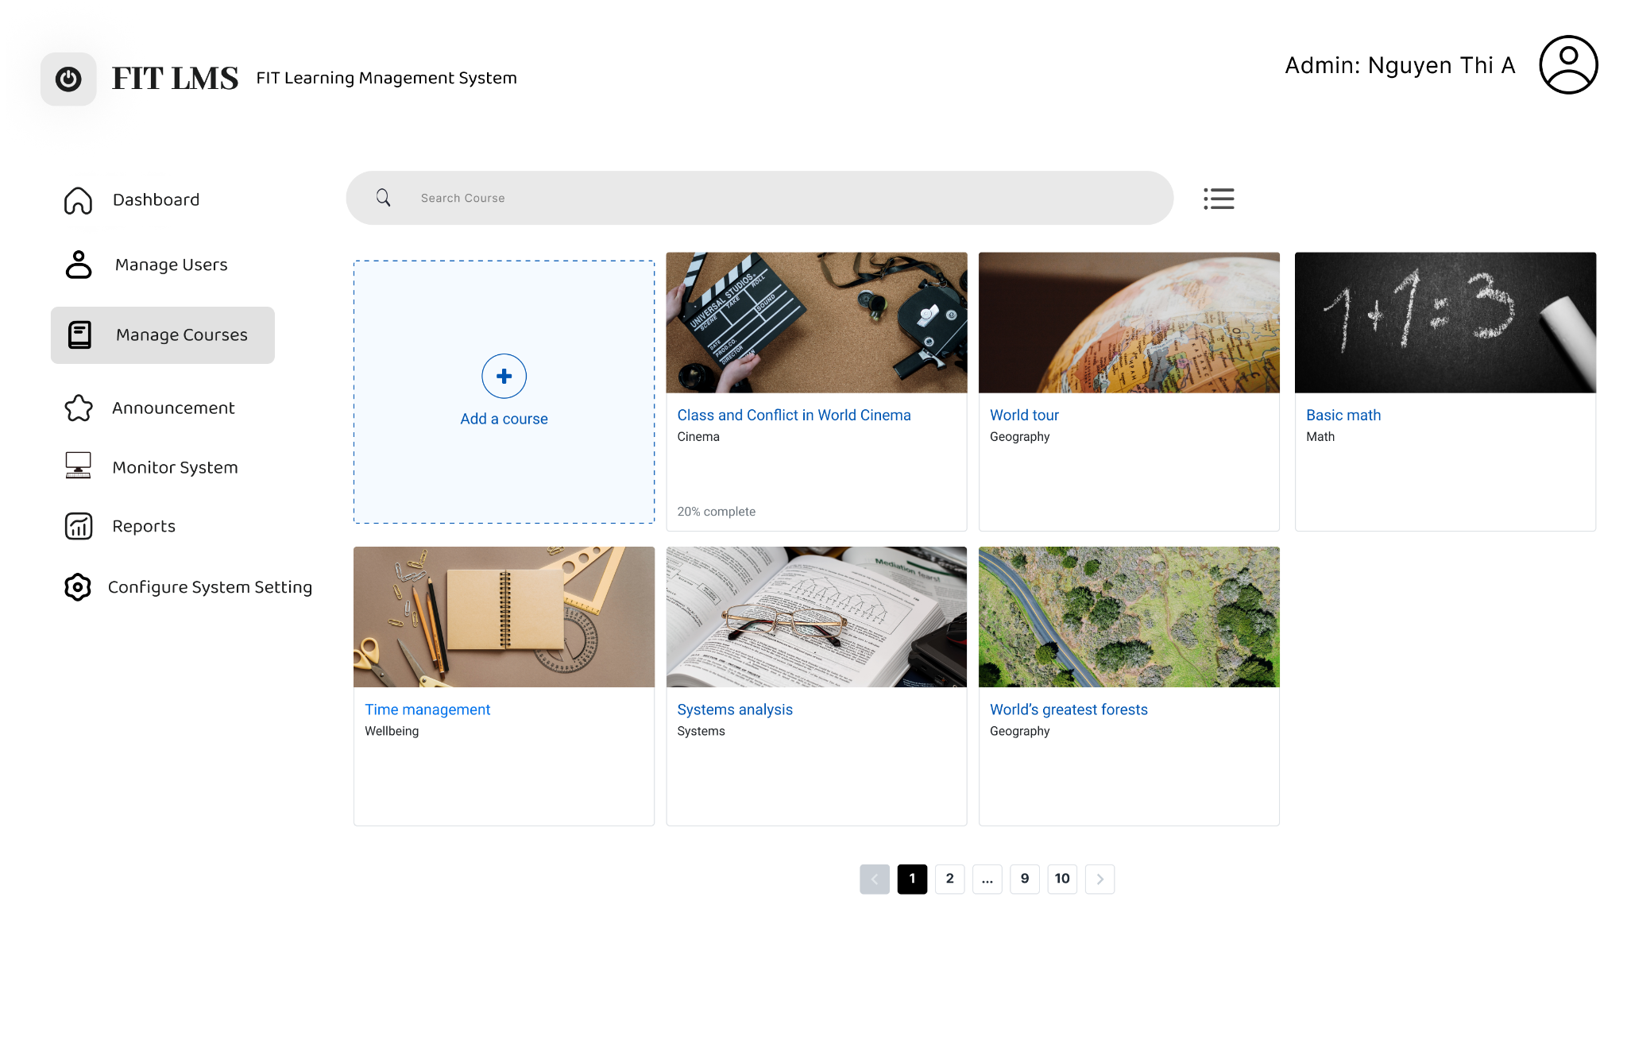

*Figure 1: The Course Management View with the “Add a course” option. There is pagination at the bottom of the view*

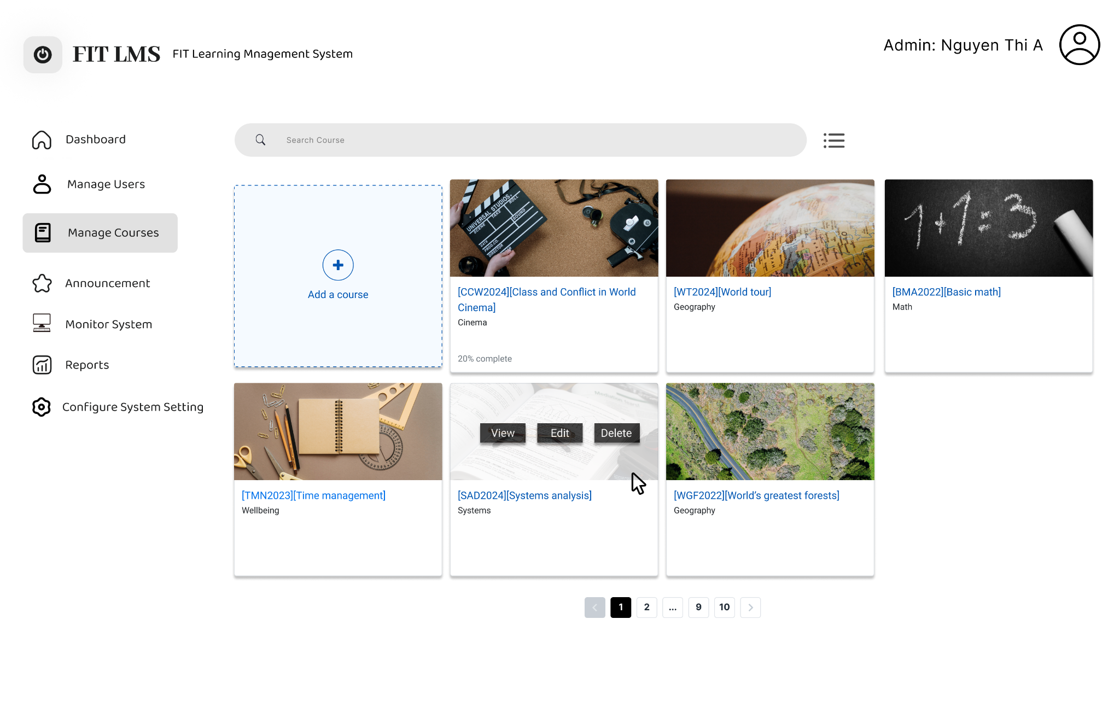

*Figure 2: When hovering over any course, the image will be blurred, and 3 buttons will appear for the admin to choose action.*

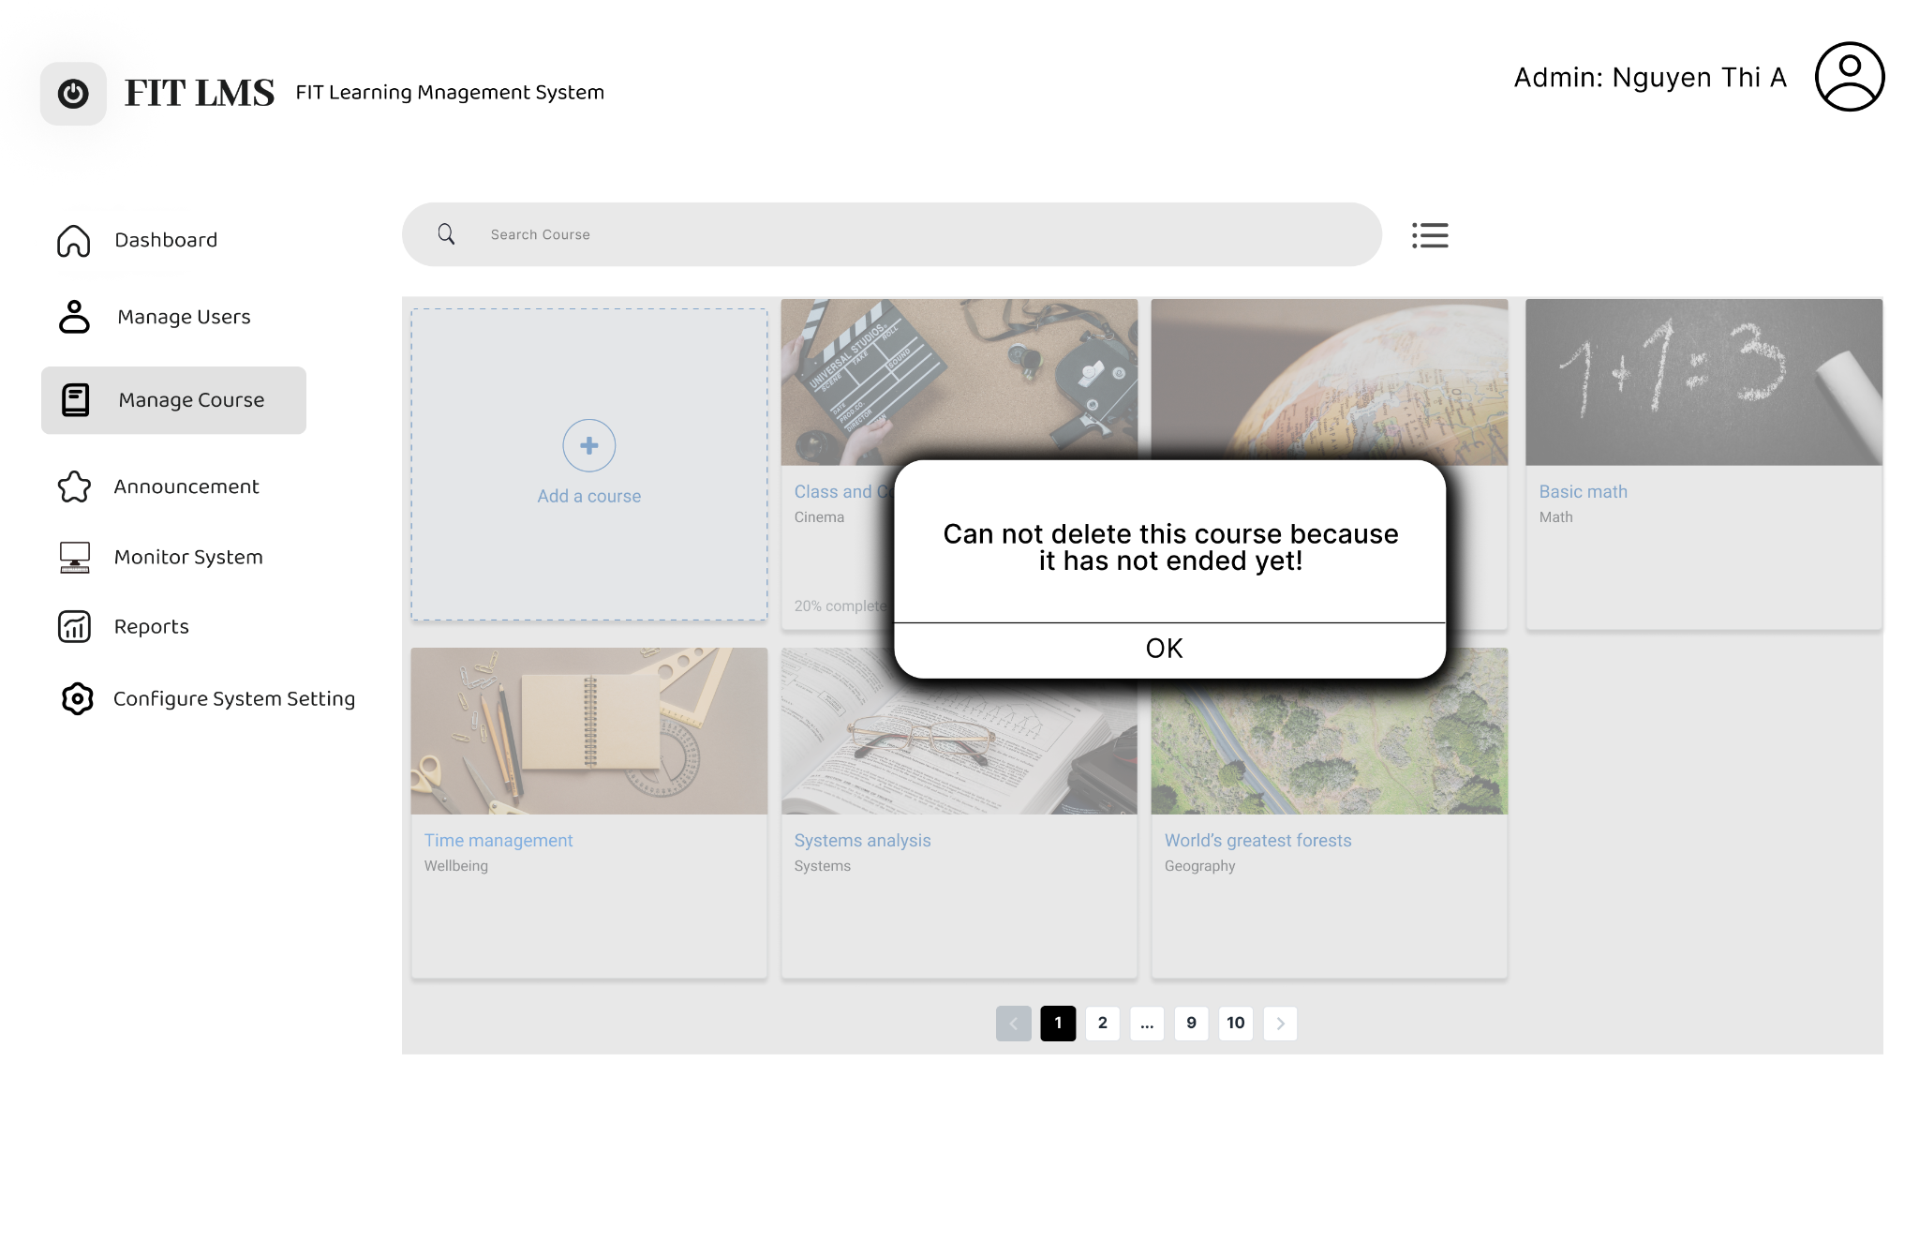

*Figure 3: Error message when the course has not ended and the admin is not allowed to delete.*

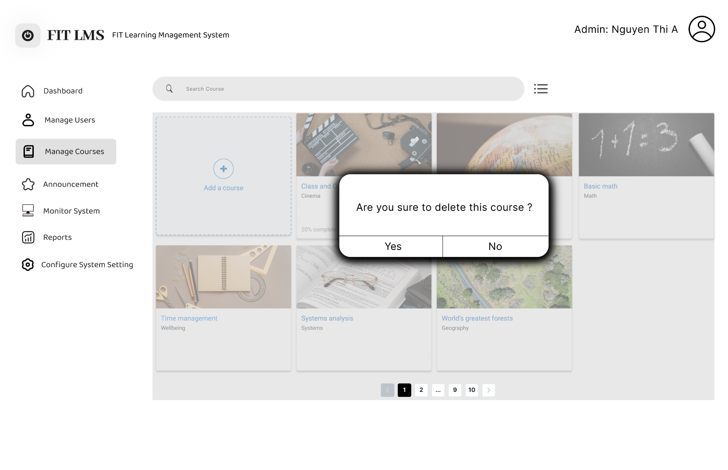

*Figure 4: Confirmation to delete the course*

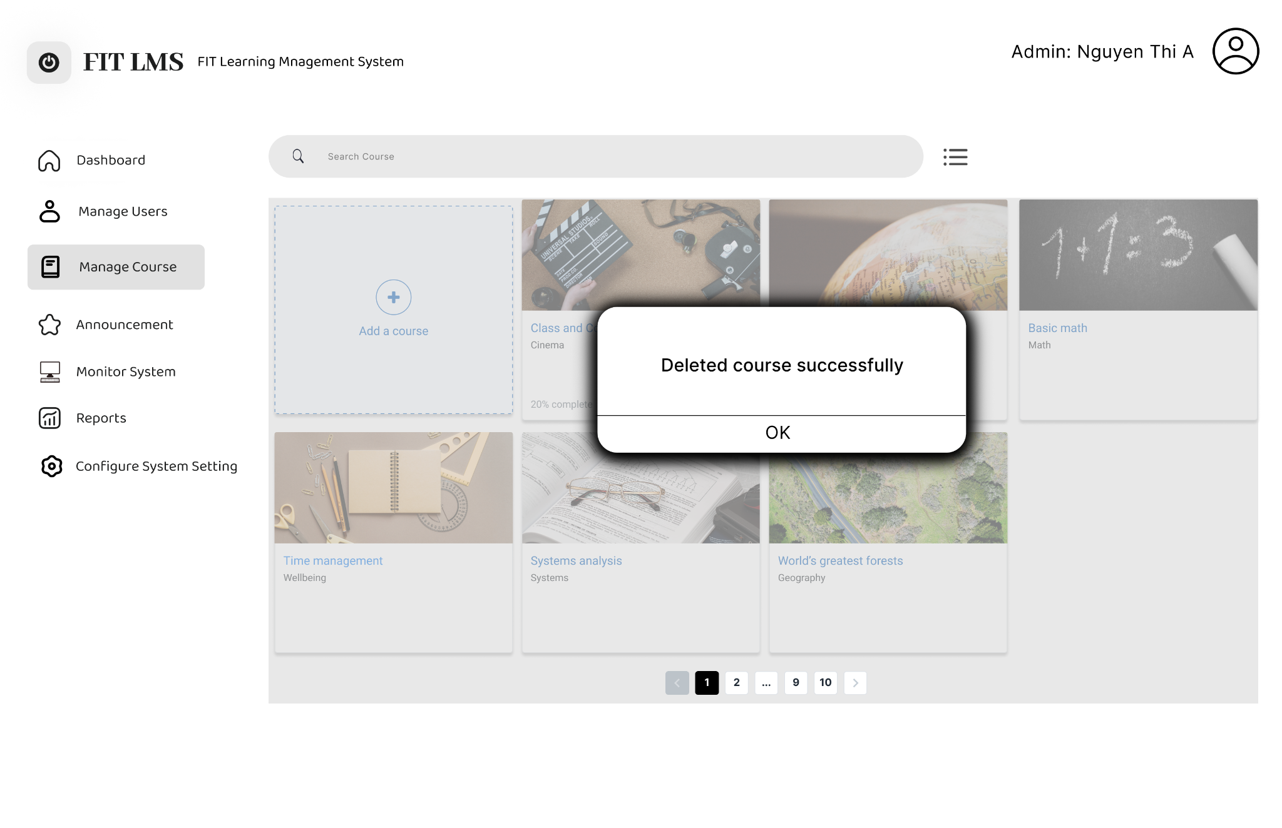

*Figure 5: A message appears when deleted successfully.*

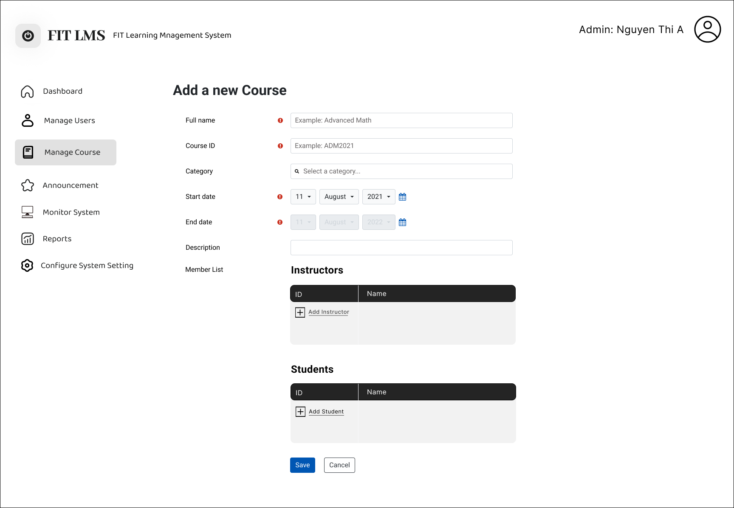

*Figure 6: The “Add a new course” view with the fields needed. The required fields are marked with a mini-red icon. The member list is divided into 2 sections so that the assigned members have the correct roles and access.*

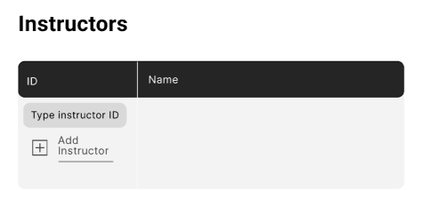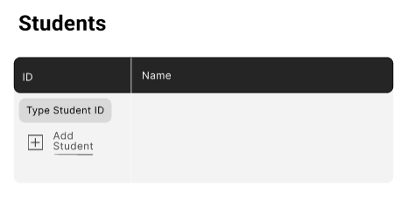

*Figure 7: The type box appears after the admin clicks “Add Instructor” or “Add Student”, allowing the admin to type in ID and search for accounts.*

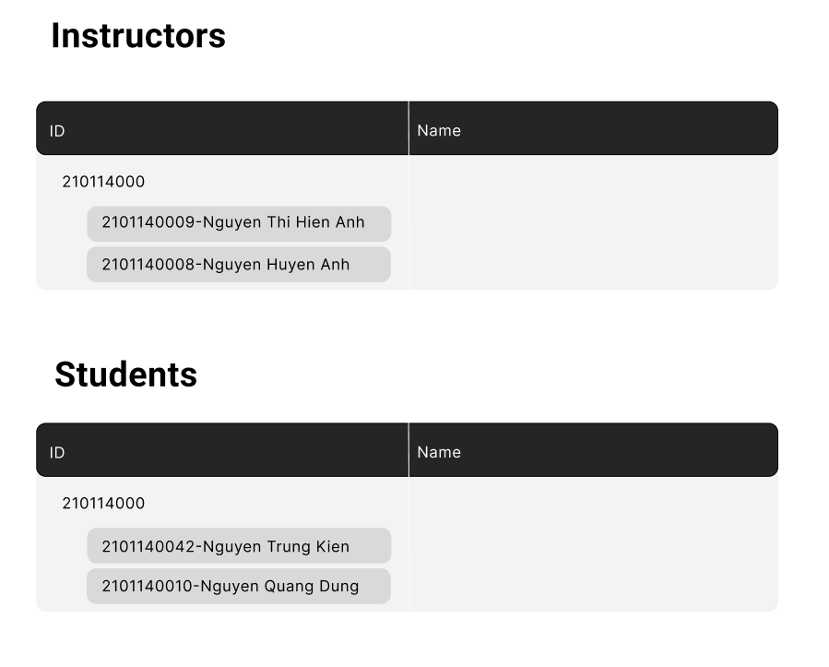

*Figure 8: Suggestion when typing the ID*

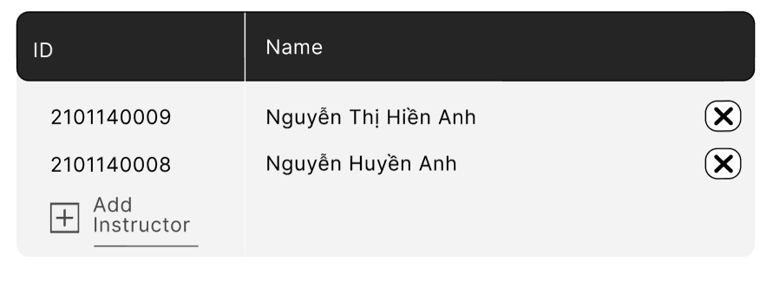

*Figure 9: When adding members successfully, the member ID and name will appear in the table with the remove button*

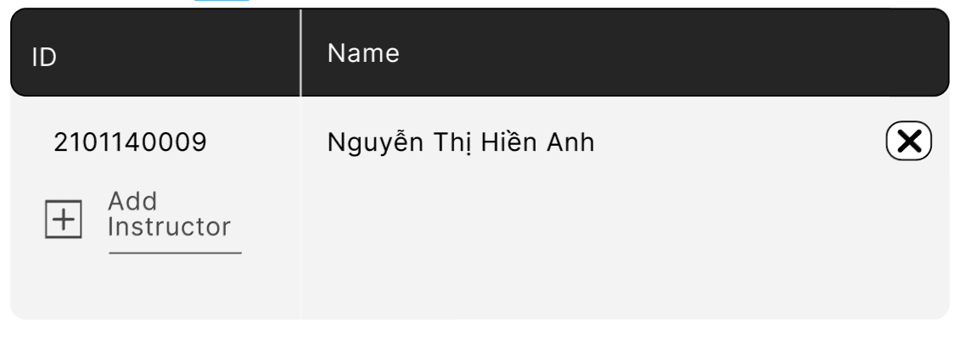

*Figure 10: After clicking remove button, the member disappear from the table*

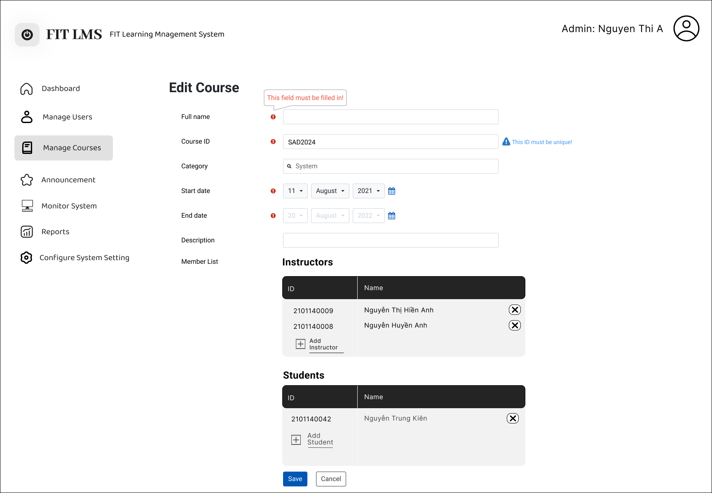

*Figure 11: The “Edit course” view with error message reminds the admin to fill in the required fields and choose a unique ID.*

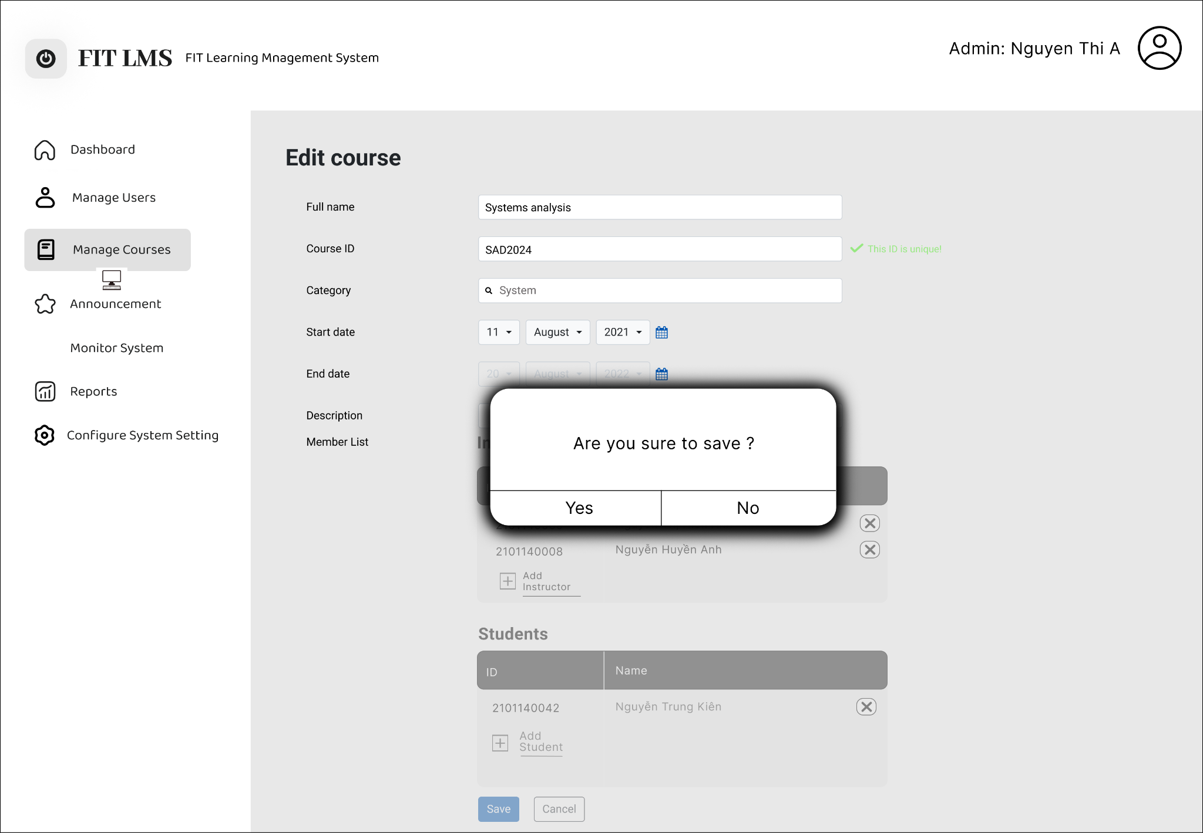

*Figure 12: The system only allows users to save when the required fields are filled in and the ID is unique.*

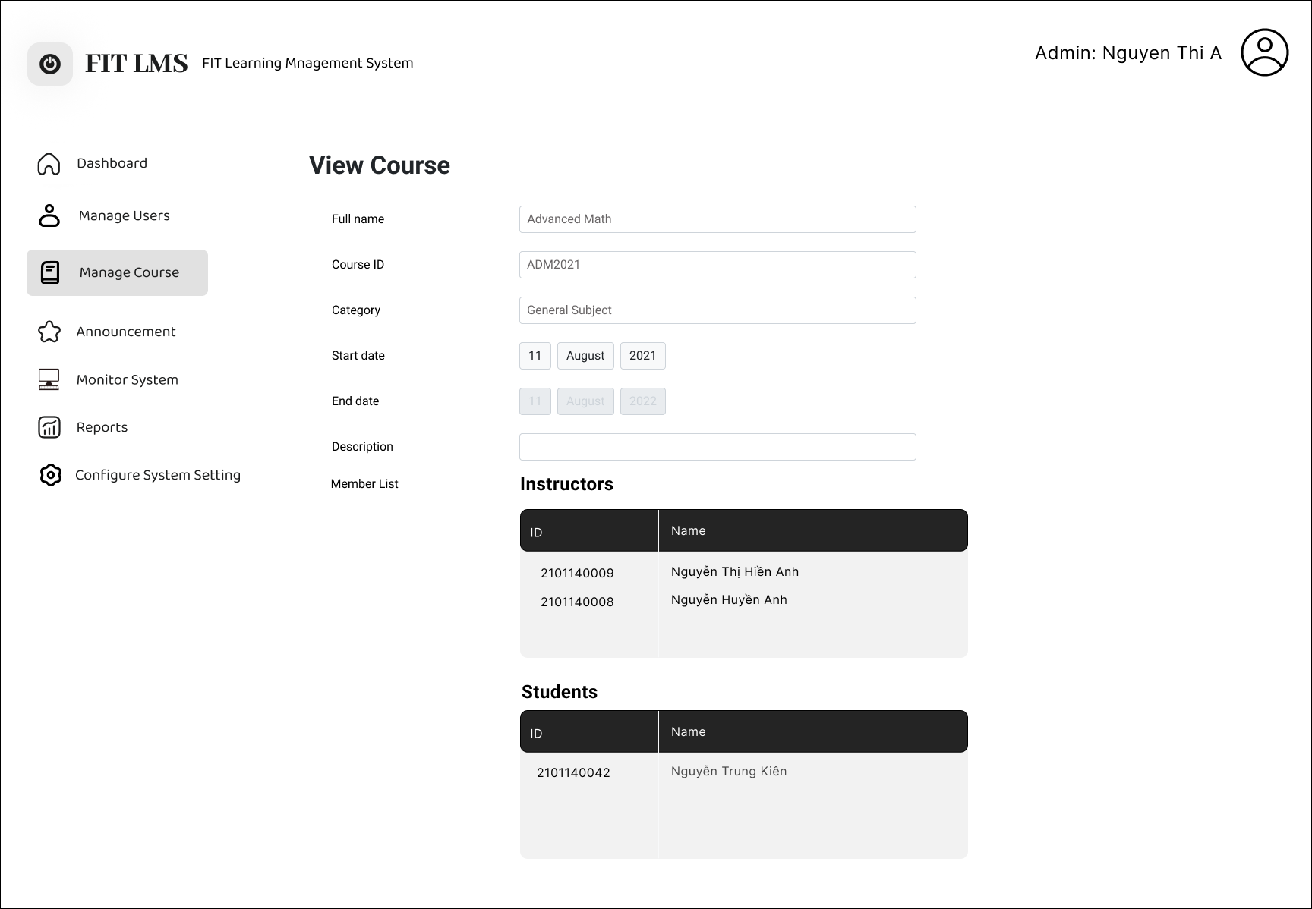

*Figure 13: The Course Details view*

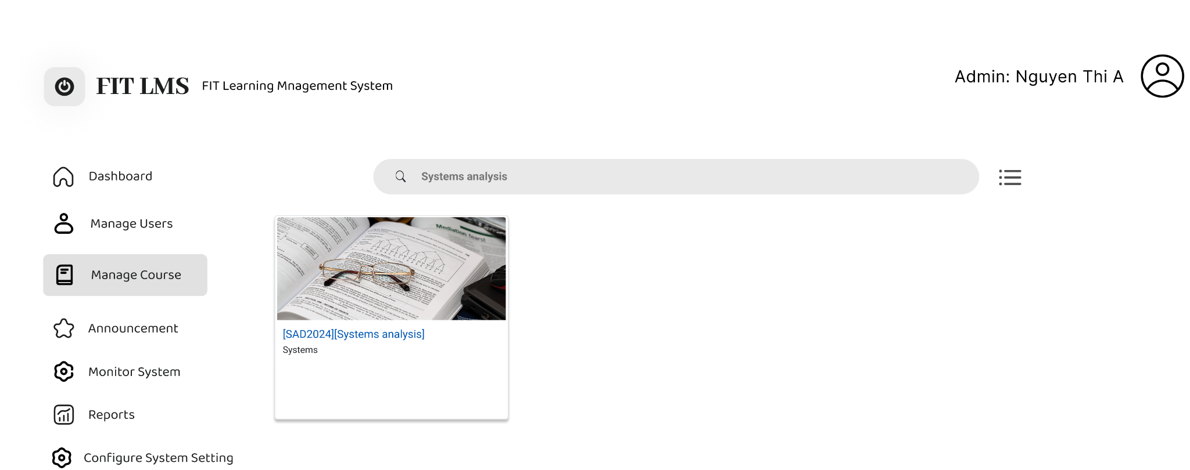

*Figure 14: The result appears when the user enters the search keywords on the search bar and clicks enter.*